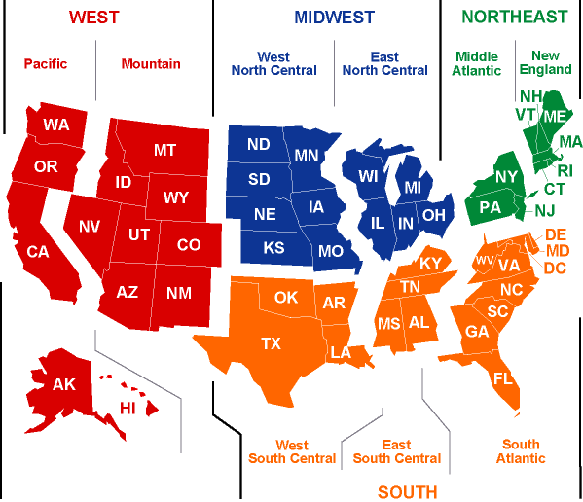

**Kruskal-Wallis Test on EDUCATION INDEX**

CBDivisions N Median Ave Rank Z

1 6 5.808 43.8 3.13

2 3 5.740 38.7 1.52

3 5 5.188 30.4 0.70

4 7 5.113 26.6 0.11

5 9 4.995 28.0 0.44

6 4 4.342 7.5 -2.59

7 4 4.217 5.5 -2.87

8 8 4.664 19.4 -1.37

9 5 5.191 30.0 0.63

Overall 51 26.0

**Kruskal-Wallis Test on % Enrollment**

CBDivisions N Median Ave Rank Z

1 6 89.80 42.8 2.95

2 3 89.73 40.0 1.68

3 5 88.51 36.6 1.68

4 7 86.95 23.3 -0.52

5 9 86.94 30.0 0.89

6 4 85.57 18.3 -1.09

7 4 83.71 9.8 -2.28

8 8 84.06 13.4 -2.62

9 5 85.67 22.8 -0.51

Overall 51 26.0

H = 25.65 DF = 8 P = 0.001

**Kruskal-Wallis Test on HS Grad Rate**

CBDivisions N Median Ave Rank Z

1 6 81.25 38.8 2.25

2 3 83.00 33.7 0.92

3 5 78.70 33.0 1.11

4 7 83.10 44.0 3.45

5 9 68.60 14.9 -2.46

6 4 69.85 14.3 -1.65

7 4 73.15 17.4 -1.21

8 8 76.20 21.4 -0.96

9 5 73.80 17.4 -1.36

Overall 51 26.0

H = 27.91 DF = 8 P = 0.000

**Kruskal-Wallis Test on Median Personal Earnings**

CBDistricts N Median Ave Rank Z

1 6 31693 34.5 1.49

2 3 31963 42.3 1.96

3 5 27805 28.2 0.35

4 7 26801 20.9 -0.99

5 9 29453 31.1 1.14

6 4 25953 8.8 -2.42

7 4 25820 12.0 -1.96

8 8 27588 19.6 -1.32

9 5 31766 37.0 1.74

Overall 51 26.0

H = 20.74 DF = 8 P = 0.008

**Kruskal-Wallis Test on EDUCATION INDEX**

CBRegions N Median Ave Rank Z

1 9 5.770 42.1 3.58

2 12 5.188 28.2 0.58

3 17 4.489 17.9 -2.76

4 13 5.150 23.5 -0.71

Overall 51 26.0

H = 16.27 DF = 3 P = 0.001

**Kruskal-Wallis Test on % Enrollment**

CBRegions N Median Ave Rank Z

1 9 89.73 41.9 3.53

2 12 87.16 28.8 0.75

3 17 85.69 22.5 -1.20

4 13 85.00 17.0 -2.53

Overall 51 26.0

H = 16.44 DF = 3 P = 0.001

**Kruskal-Wallis Test on HS Grad Rate**

CBRegions N Median Ave Rank Z

1 9 81.70 37.1 2.47

2 12 82.20 39.4 3.58

3 17 71.90 15.4 -3.62

4 13 74.80 19.8 -1.73

Overall 51 26.0

H = 25.75 DF = 3 P = 0.000

**Kruskal-Wallis Test on Median Personal Earnings**

CBRegions N Median Ave Rank Z

1 9 31963 37.1 2.47

2 12 27401 23.9 -0.56

3 17 26357 21.4 -1.58

4 13 29507 26.3 0.09

Overall 51 26.0

H = 6.93 DF = 3 P = 0.074

Education Index vs Median Personal Earnings, State Spending on Education Research and Development, and Per Pupil Spending (R2=73.6%)



Education Index vs. Median Personal Earnings, % Economically Disadvantaged Students (R2=67.0%)



Education Index vs. Median Personal Earnings, % Economically Disadvantaged Students (R2=73.1%) WITHOUT NEVADA AND WASHINGTON DC



HS Grad Rate vs. Median Personal Earnings, % Economically Disadvantaged Students (R2=51.4%)